
Aditya University
School of Computing Department of Computer Applications

IoT PROJECT –REVIEW-I

Project: Smart Water Level Indicator

Programme: MCA Year: 2 Semester: III Review-I: 24-08-2026 to 28-08-2026
Student Team:
- Pravallika Vasa
- Nissi Mogili
- A.H.S Srivalli
- K. Mahima
Project Guide: Miss Uppalapati Naga Ratna Kumari

Project Abstract:

The Smart Water Level Indicator is a low-cost and efficient system designed to monitor and indicate the water level in a storage tank. The system uses an ultrasonic sensor to measure the distance between the sensor and the water surface. The measured data is processed by a microcontroller, which determines the current water-level status.
The system provides visual indication through LEDs for different water levels such as Low, Medium, High,
and Full. A buzzer alert is activated when the water reaches the critical/full level, helping users take timely action. The main aim is to prevent overflow and reduce water wastage. The proposed system aims to prevent tank overflow, reduce water wastage, and minimize manual monitoring. It can also be extended with IoT-based mobile notifications and automatic pump control in the future.

Introduction:

The Smart Water Level Indicator is proposed as a simple solution to overcome this problem. The system automatically detects the water level inside a tank and provides an indication to the user. An ultrasonic sensor is positioned at the top of the tank and measures the distance between the sensor and the water surface. Since the sensor does not need to come into direct contact with water, it can provide a convenient method of level detection.
The sensor readings are processed by a microcontroller, which compares the measured values with predefined threshold levels. Depending on the detected level, LEDs indicate whether the tank has Low, Medium, High, or Full Status using LED’s. A buzzer alert is provided when the water reaches the critical/full level, allowing the user to take immediate action.
The system focuses on being low-cost, simple, reliable, and easy to implement. Proper calibration and sensor positioning can improve the accuracy of the readings. For outdoor applications, electronic components can be protected using a waterproof enclosure.
In the future, the system can be enhanced with IoT-based monitoring, mobile notifications, automatic pump control, and remote access, making it a more advanced smart water-management system.

Problem Statement:

Traditional water tank monitoring systems generally require manual checking inspection and do not provide continuous information about the water level.

The major problems identified are:

- Difficulty in checking the water level manually.
- Water overflow due to delayed monitoring.
- Unnecessary wastage of water.
- Lack of automatic water level indication.
- No alert when the tank reaches its maximum level.
- Inconvenience in monitoring tanks regularly.
- Increased effort and time required for manual checking.

Therefore, a Smart Water Level Indicator is proposed to provide automatic water level monitoring and alerts, helping to reduce water wastage and improve efficient water management.

Project Objectives:
- To monitor the water level in real time.
- To detect Low, Medium, High, and Full water levels.
- To provide clear LED-based level indication.
- To generate a buzzer alert at the critical/full level.

To prevent water overflow and reduce water wastage.
- To develop a simple, low-cost, and reliable solution.

Proposed IoT Modules / Functionalities:
Water-Level Sensing – Detects the water level using an ultrasonic sensor.
Controller Module – Processes sensor readings and determines the water-level status.
LED Indication – Displays the current water-level category.
Buzzer Alert – Alerts the user when the tank reaches the full/critical level.
IoT Monitoring – Future enhancement for sending water-level data to a mobile device.
Automatic Pump Control – Future enhancement to control the pump based on water level.

Hardware Requirements:
- Arduino Uno / ESP32
- Ultrasonic Water Level Sensor
- LED Indicators
- Buzzer
- Resistors
- Breadboard
- Jumper Wires
- Power Supply / USB Cable

Software Requirements:

- Arduino IDE
- Embedded C / Arduino
Programming
- Serial Monitor for Testing & Debugging

Input and Expected Output:
Input:
Distance between the ultrasonic sensor and water surface
Tank height
Predefined water-level thresholds

Expected Output:
Low Level → White/Yellow LED indication Medium Level → Green LED indication High Level → Red LED indication
Full Level → Buzzer Alert
Real-time water-level status displayed through the LED indicators
Alert when the water reaches the critical/full level

Design Methodology: Algorithm & System Flow & Flowchart:

Algorithm:

- Start the system.
- Initialize the ultrasonic sensor, LEDs, and buzzer.
- Measure the distance between the sensor and water surface.
- Calculate the water level based on the tank height.
- Compare the water level with predefined thresholds.
- Turn ON the corresponding LED based on the water level.
- Activate the buzzer when the water reaches the critical/full level.
- Continuously repeat the measurement and indication process.

System Flow:
Water Tank → Ultrasonic Sensor → Arduino/ESP32 → Water-Level Calculation → Threshold Comparison → LED Indication + Buzzer Alert

Flowchart:

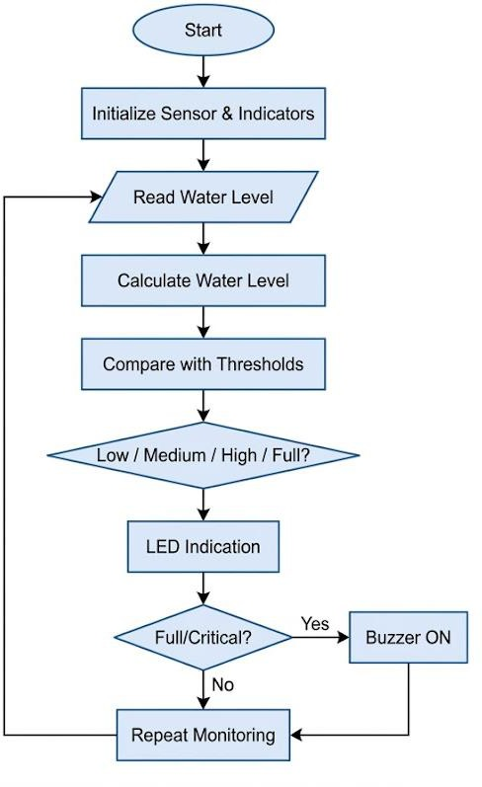

Implementation Progress:

Problem Identification – Water overflow and manual monitoring issues identified. Component Selection – Sensor, Arduino/ESP32, LEDs, buzzer and other components selected. Sensor Integration – Water-level sensor connected and tested.
Circuit Setup – LEDs and buzzer integrated with the controller.
Water-Level Detection – Low, Medium, High and Full levels being implemented.
Calibration & Testing – Sensor readings and threshold values being calibrated.
Prototype Development – Final prototype assembly and testing in progress.

Individual Team Member Contribution
Each member should explain their individual contribution during the Review-I presentation

Team Members | Planned/Completed Contribution
Pravallika | Problem identification
Srivalli | Hardware selection and sensor interfacing
Nissi | Arduino programming and algorithm  implementation
Mahima | IoT connectivity, dashboard and testing

Challenges to be Identified:

Sensor Accuracy: Getting accurate water-level readings from the ultrasonic sensor was challenging.
Sensor Placement: Finding the correct position and angle for the sensor required testing.
Water Surface Movement: Waves or movement in the water sometimes caused fluctuating readings. Circuit Connections: Connecting the LEDs, resistors, sensor, and buzzer correctly required careful wiring.
LED Indication: Setting proper threshold values for low, medium, and high water levels required calibration.
Buzzer Activation: Ensuring the buzzer activates only at the required water level needed testing.
Calibration: Adjusting the sensor readings according to the actual tank height was necessary.

Proposed Solutions:

Sensor Accuracy: Calibrate the ultrasonic sensor and take multiple readings to improve accuracy. Sensor Placement: Position the sensor properly at the top of the tank with the correct angle and distance.
Water Surface Movement: Use multiple readings and calculate the average value to reduce fluctuations.
Circuit Connections: Follow the circuit diagram carefully and verify all connections before testing. LED Indication: Set and calibrate appropriate threshold values for Low, Medium, and High levels. Buzzer Activation: Program the buzzer to activate only when the water reaches the defined critical level.
Calibration: Measure the actual tank height and adjust the sensor readings accordingly.

Work Planned After Review-I

- Complete water-level sensor integration and calibration.
- Complete microcontroller programming and circuit connections.
- Implement accurate water-level detection.
- Set Low, Medium, High, and Full water-level thresholds.
- Implement LED indications for different water levels.
- Implement buzzer alerts for critical water levels and overflow.
- Integrate the sensor, microcontroller, LEDs, and buzzer into a single system.
- Test the prototype at different water levels.
- Improve the accuracy, reliability, and response time of the system.
- Prepare the final prototype, testing results, and project documentation.

SAMPLE PROTOTYPE

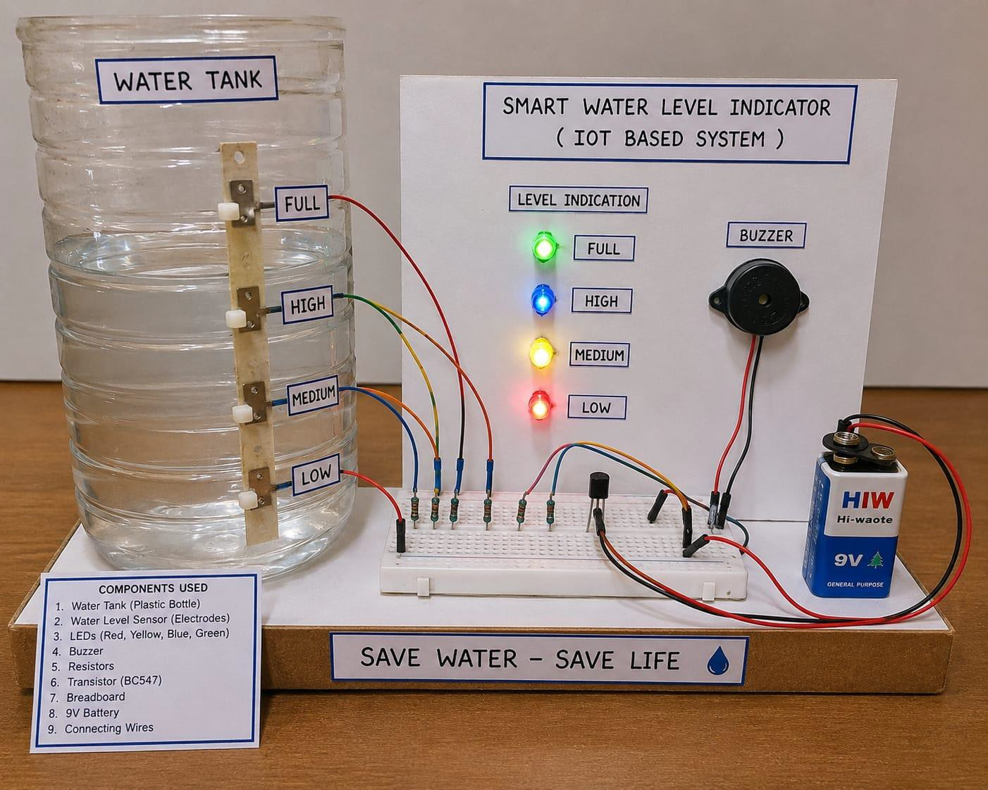

Conclusion:

- Developed a low-cost and reliable Smart Water Level Indicator for real-time tank monitoring.
- The system detects Low, Medium, High, and Full water levels and provides clear LED indications.
- Buzzer alerts help prevent tank overflow and reduce unnecessary water wastage.
- The electronic components can be protected using a waterproof enclosure, making the system suitable for outdoor conditions.
- Proper sensor placement and calibration improve the accuracy and reliability of the system.
- The proposed system provides a simple, efficient, and practical solution for smart water management.
- In the future, it can be enhanced with IoT-based mobile notifications and automatic pump control.

Thank You
(thanks to thanks a lott)

